**S**

**Verify Input file from techdata (SIT):**

**(TC: 01 &02 ) Input file should contain as per format and corresponding value mentioned from IDD and SRD. Check the Naspath is correct permissions for this new file and new file should be processed as expected & validating if HBase table is already created.**

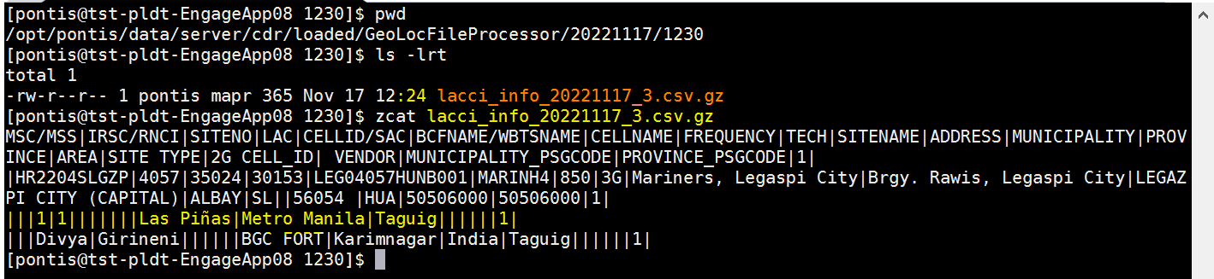

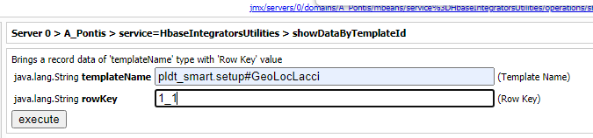

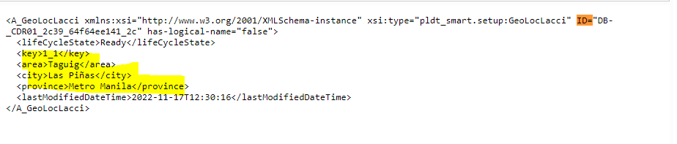

**CDR File Processor (SIT) :**

**01: Input file should contain as per format and corresponding value mentioned from IDD and SRD. Check the Naspath is correct permissions for this new file and new file should be processed as expected.**

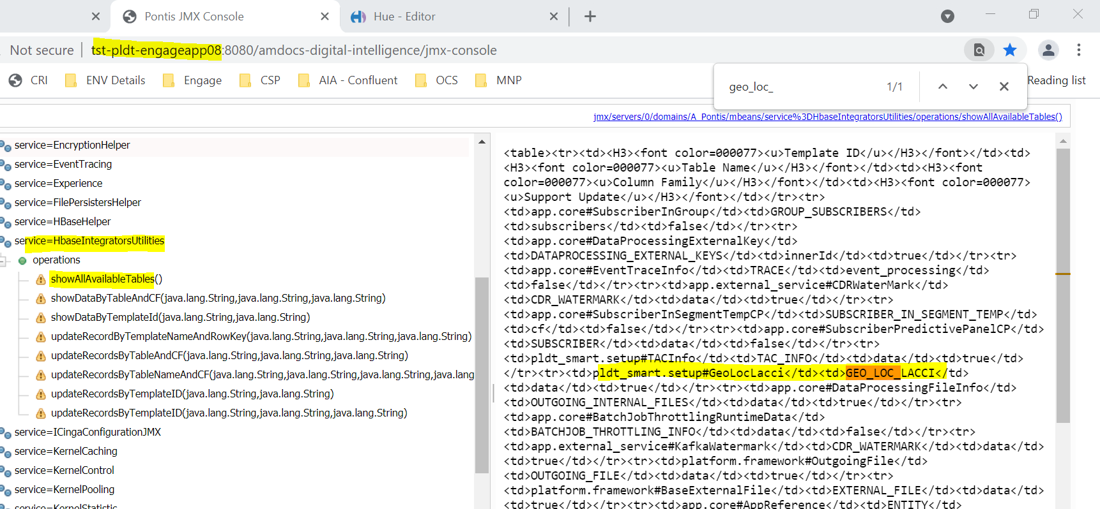

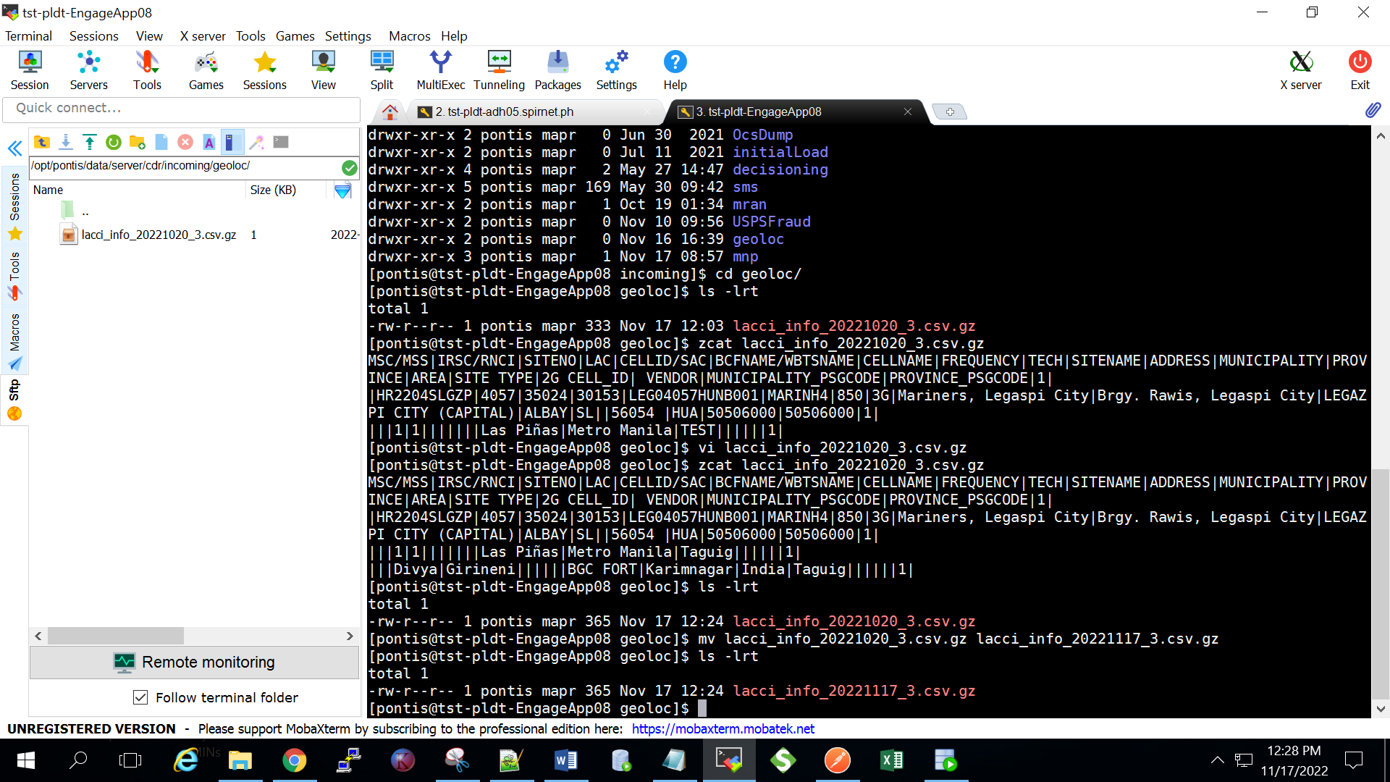

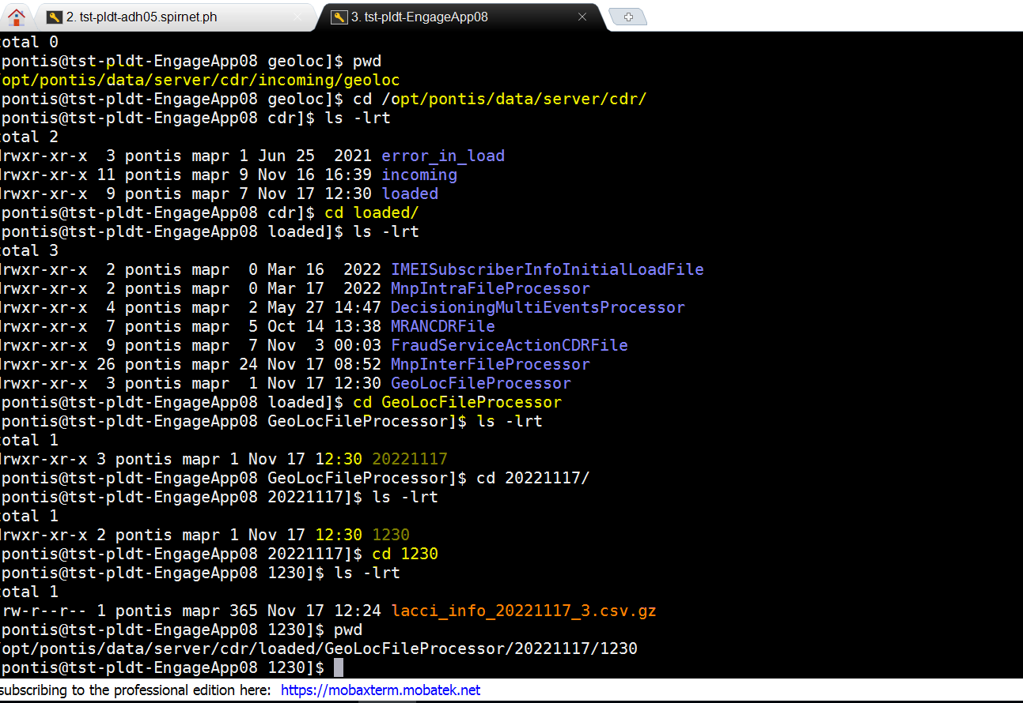

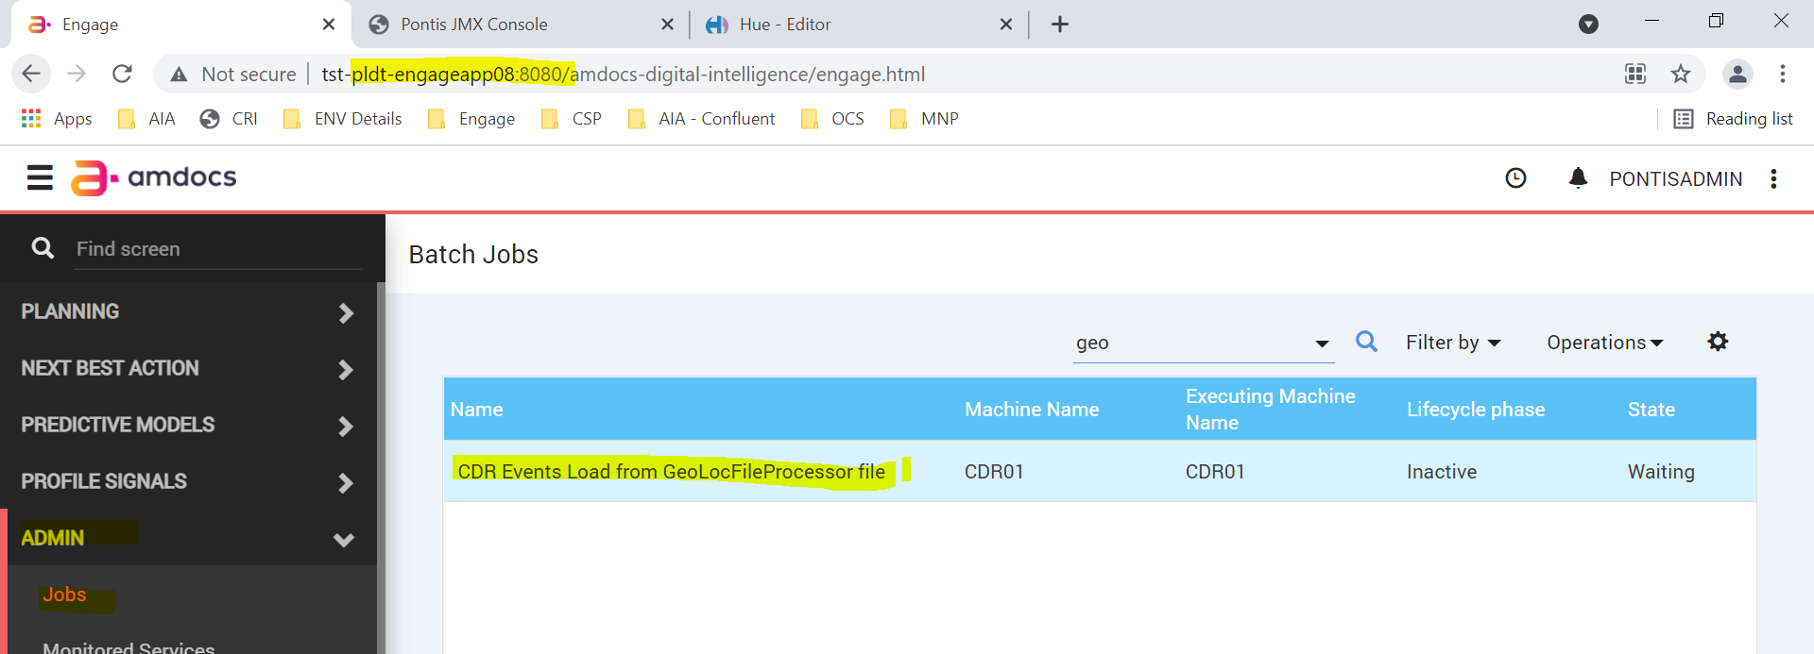

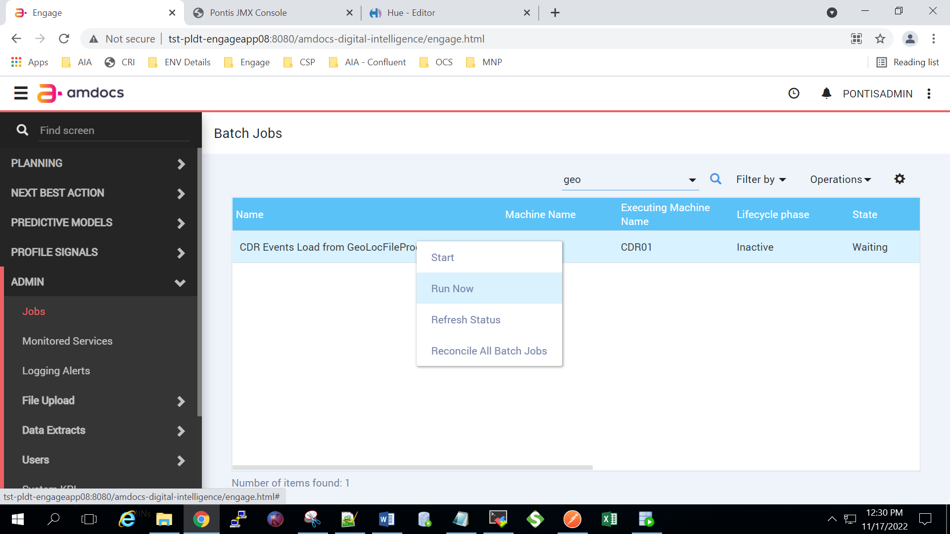

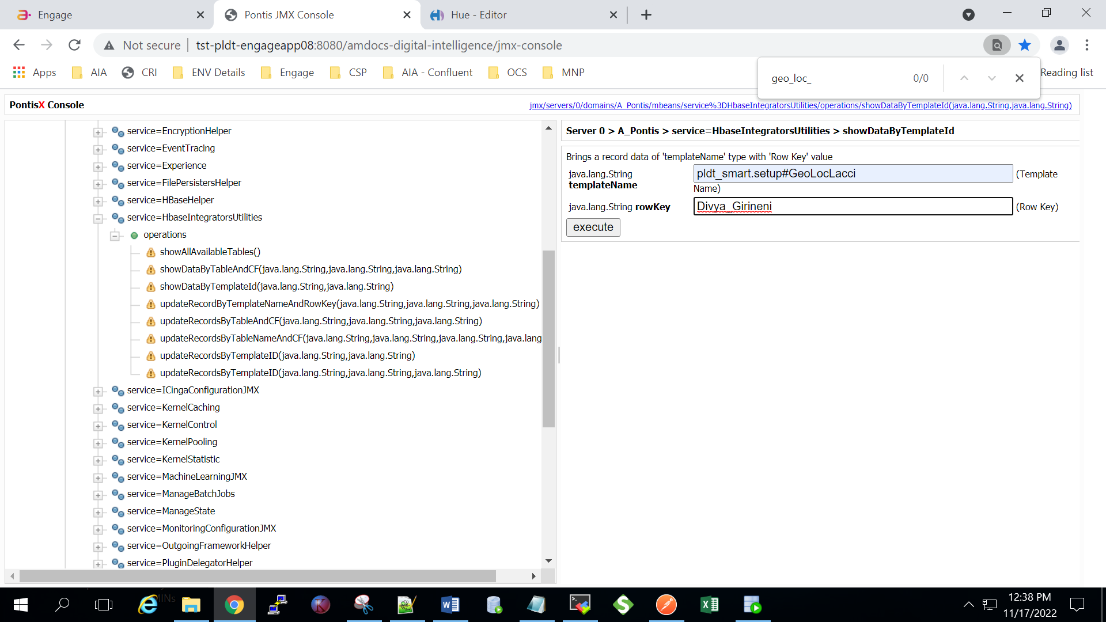

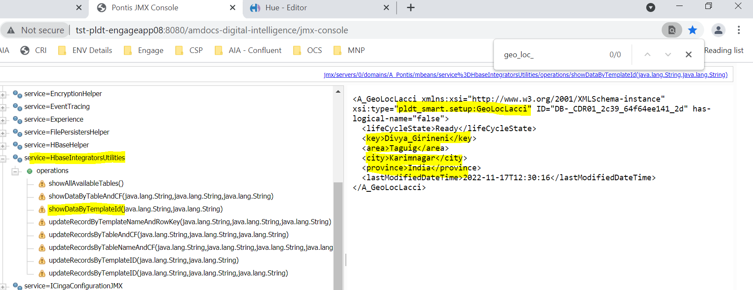

**2.Verify existing attributes in Hbase (for same subscriber) are being updated as per configuration in the Input File from tech Data:**

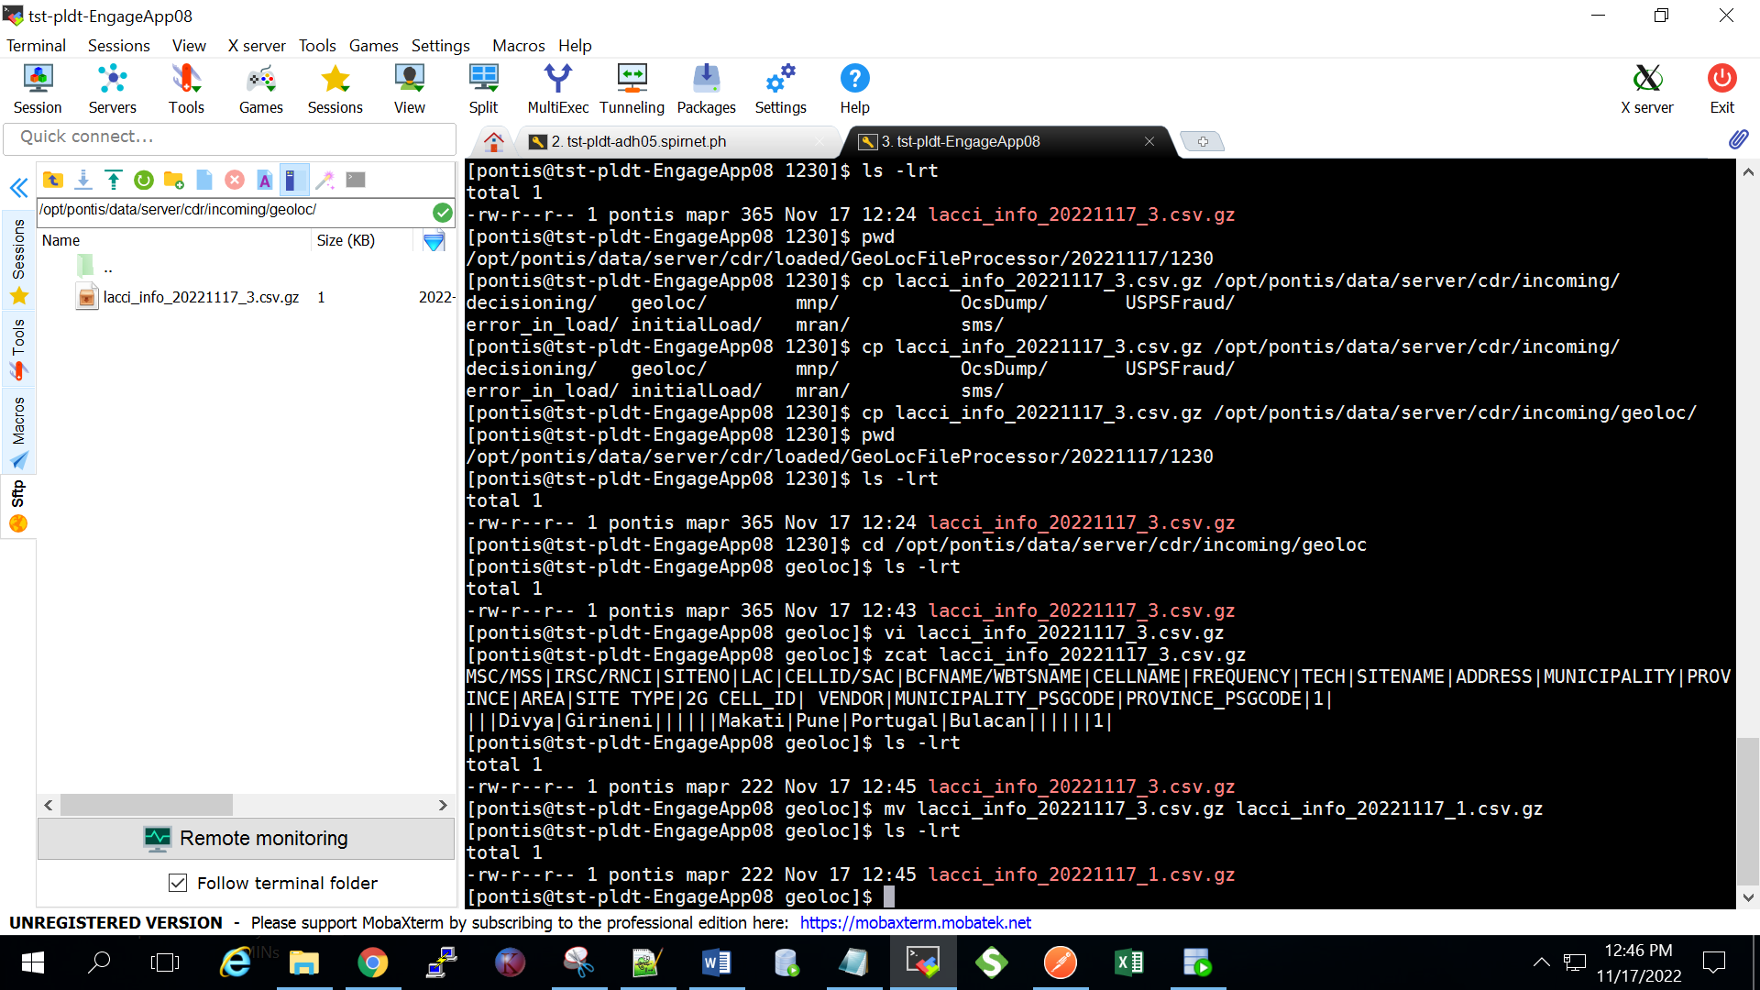

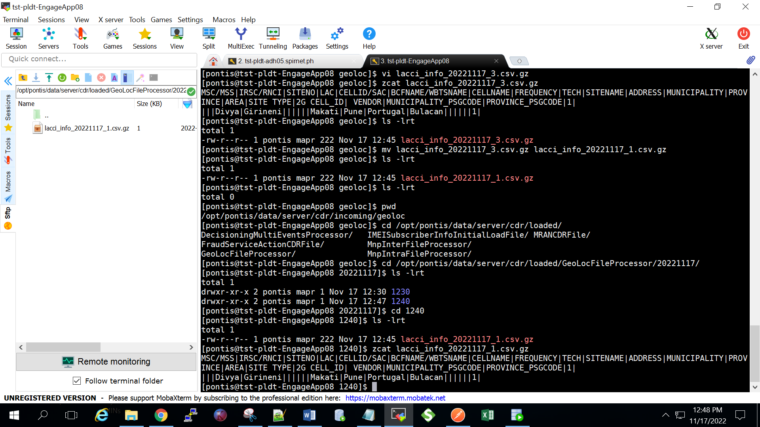

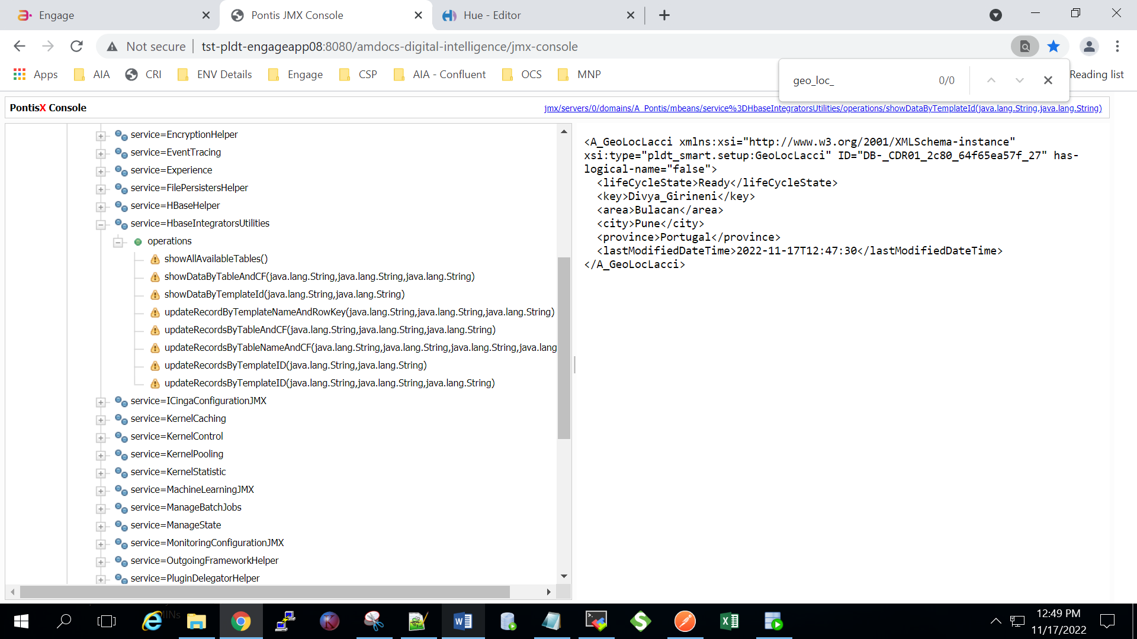

**3.Verify Hbase table is not created for the subscriber with incorrect file_format:**

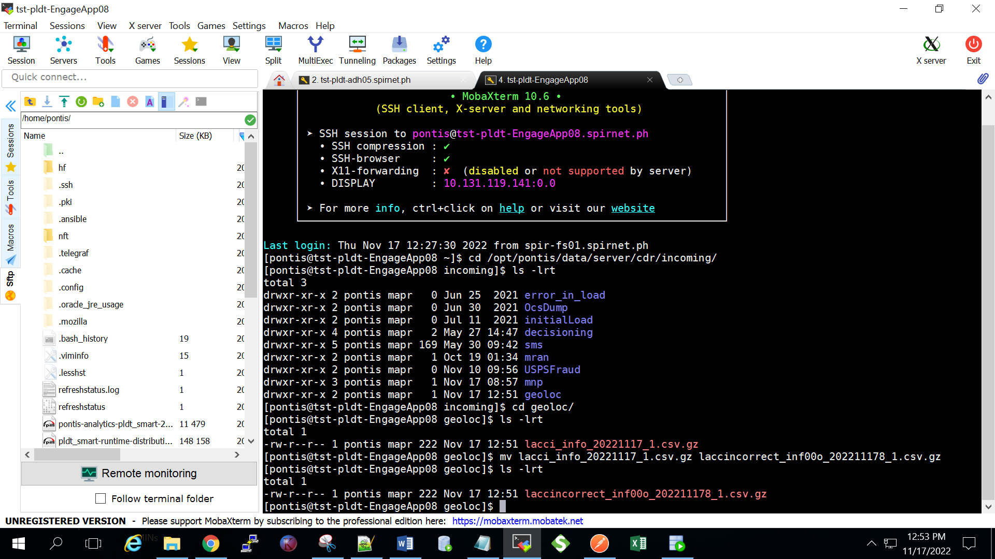

**4. For incorrect format file, it should be ignored**



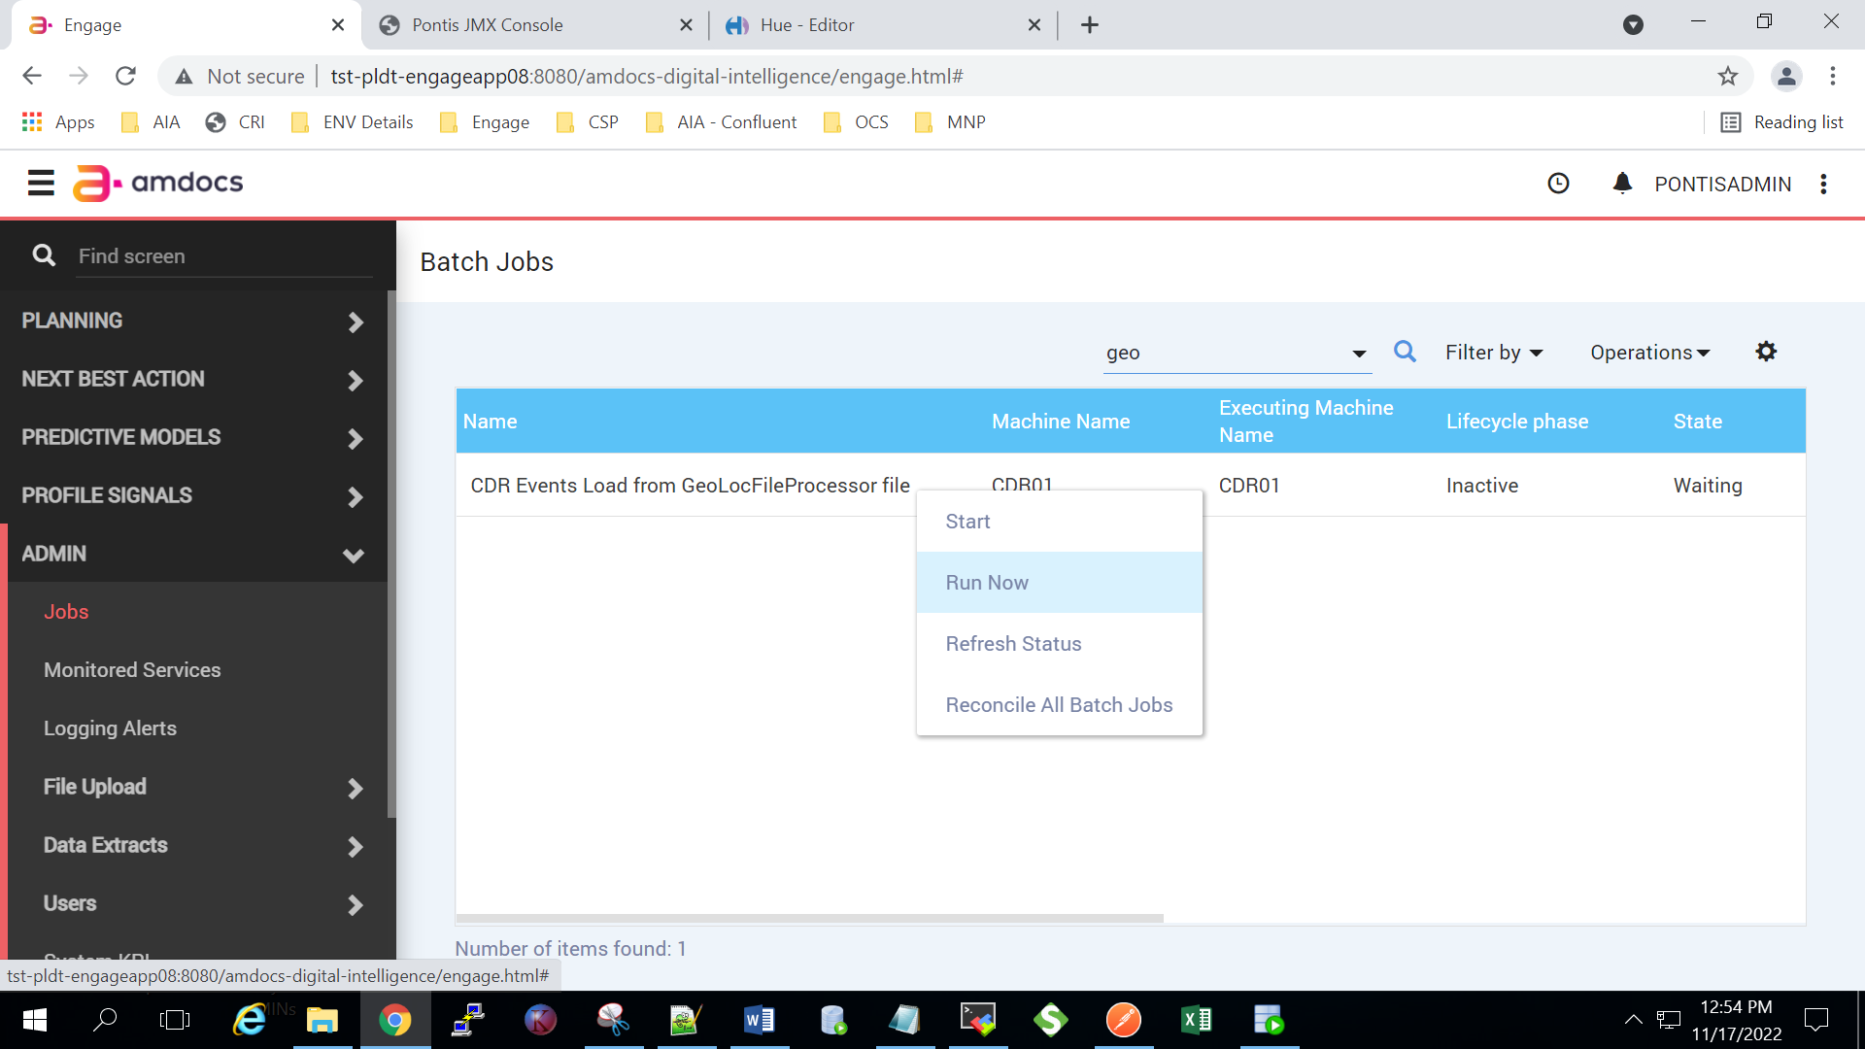

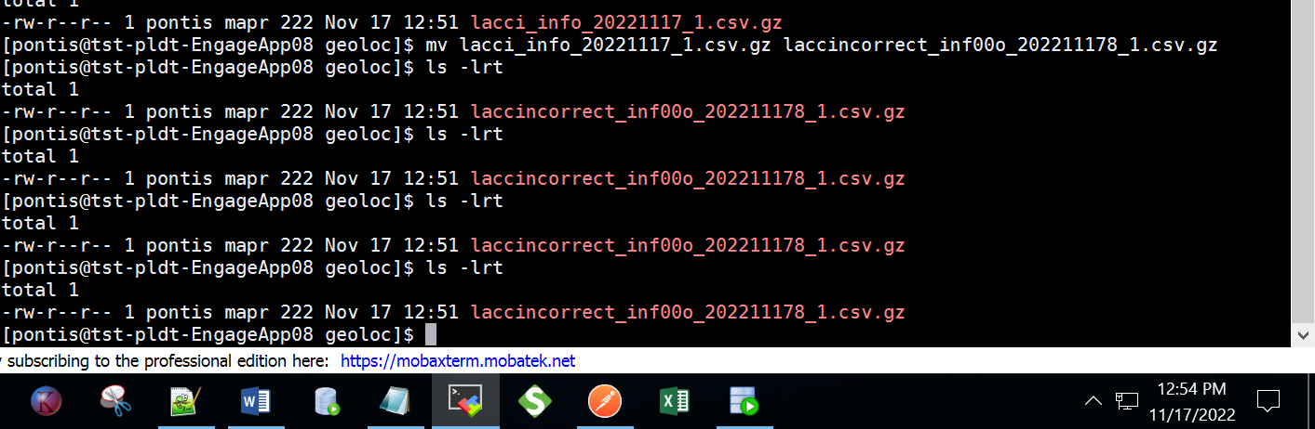

**After Triggering CDR File processor job the file is still in Geo Loc incoming**

**Decisioning Flow (SIT) :**

**1 .Validate "Geo_Loc_Exp" Experience (with false condition on city and province):**

**Prepare Input file to process with correct file name**

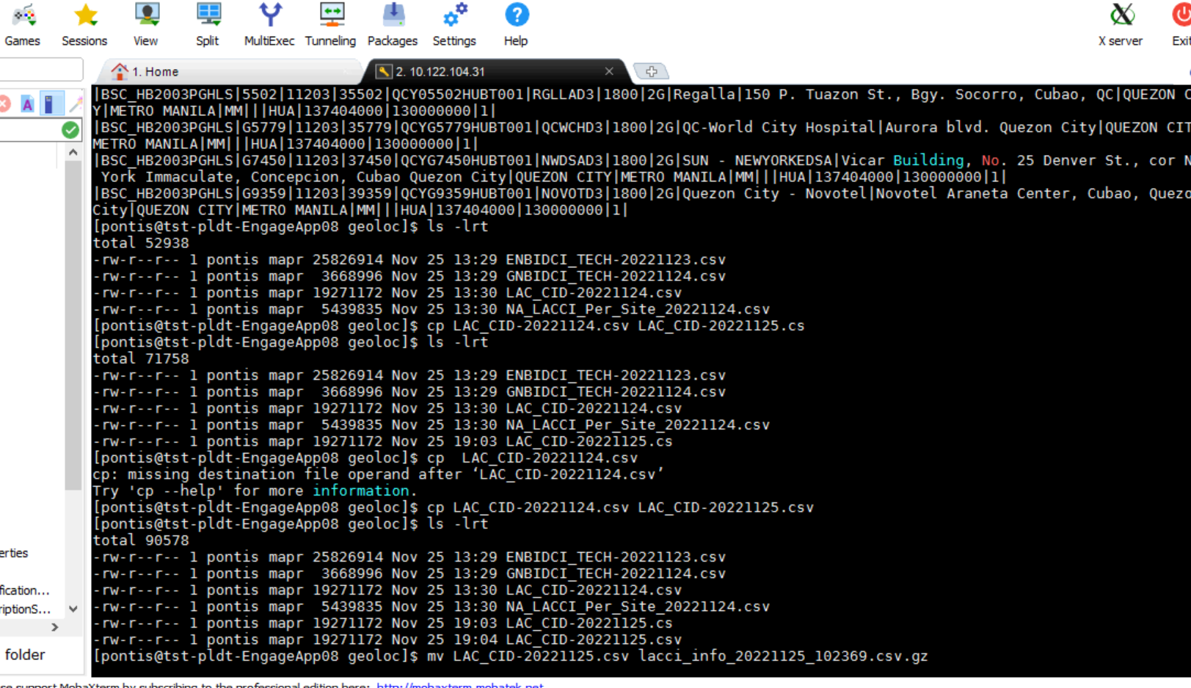

**Run the Geolocking CDR File Processor**



**Check in HBASE if table created**

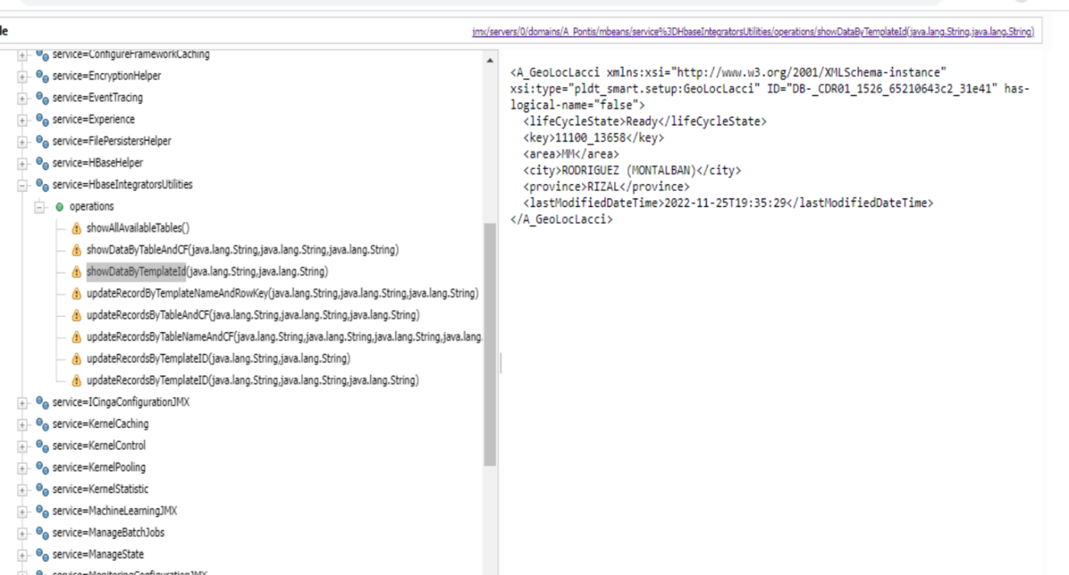

**Subscriber will be forwarded for "GLApp_Test" Experience :**

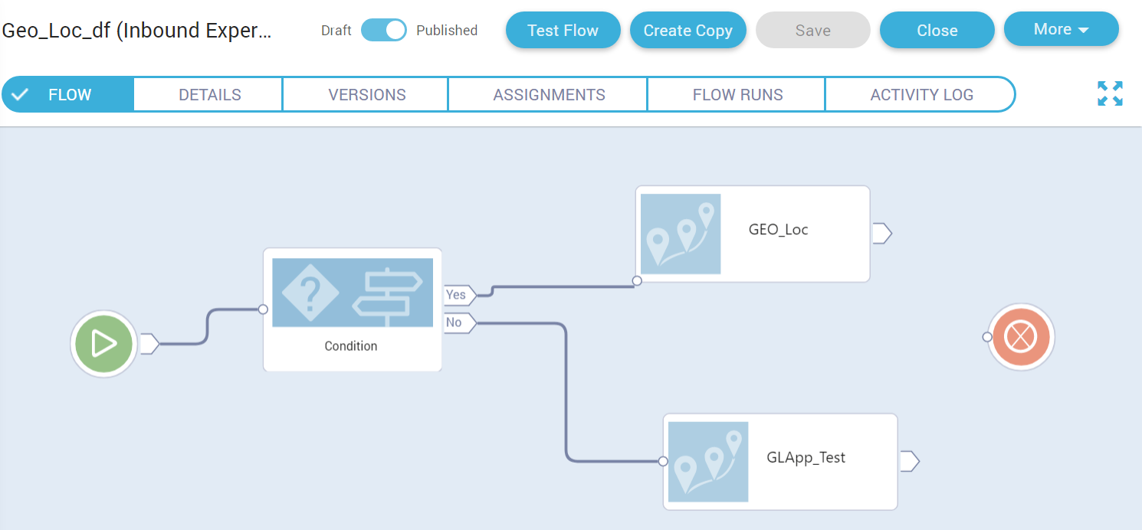

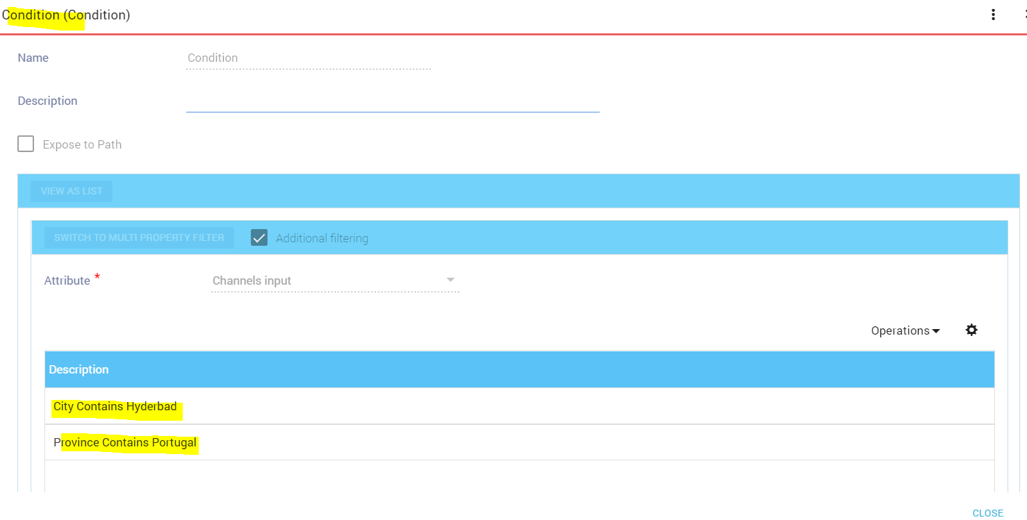

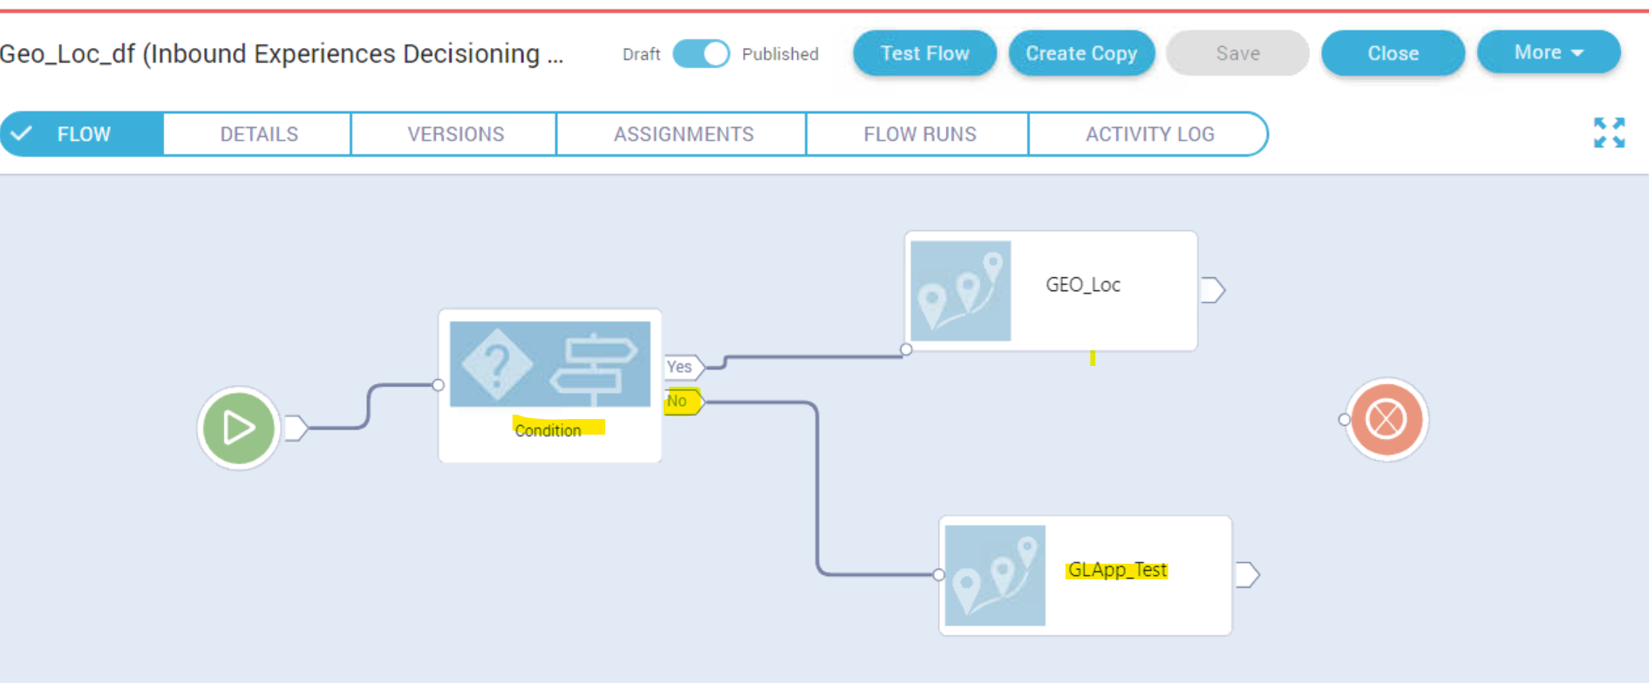

**Trigger Start Experience Event**

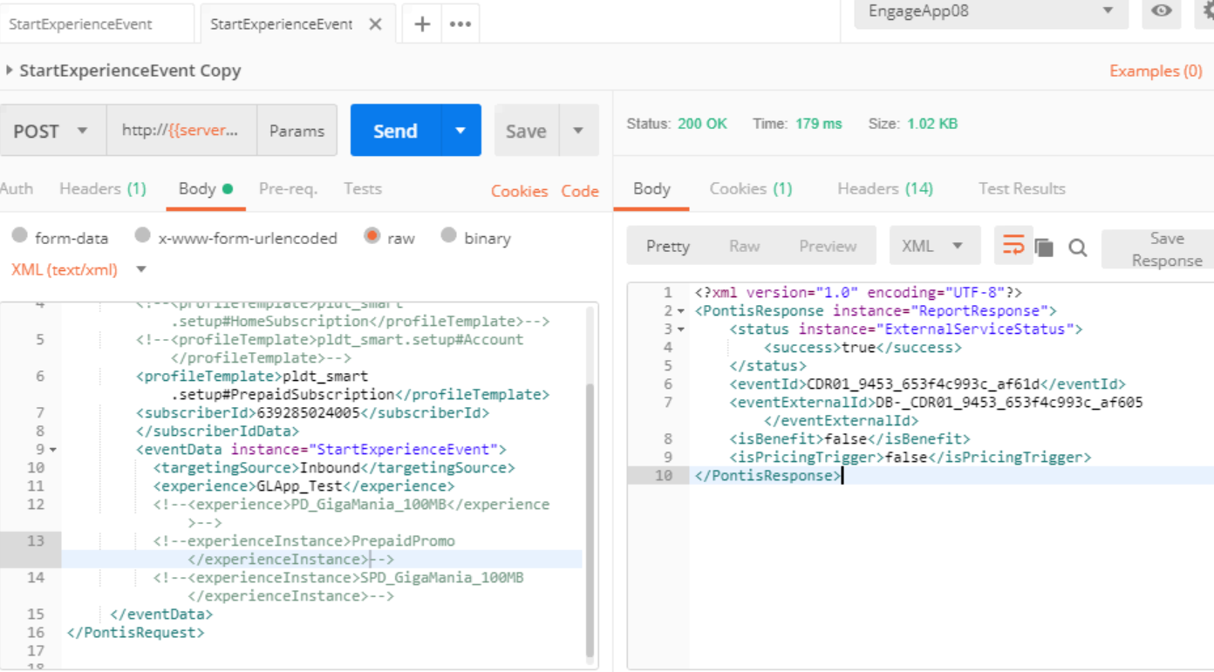

**Subscriber should receive GLApp_Test Benefit**

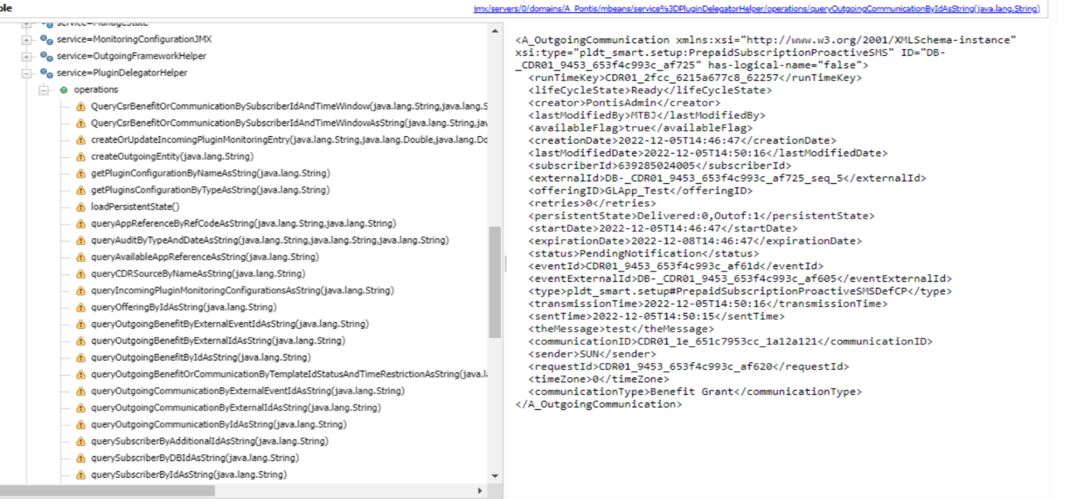

**2.Validate "Geo_Loc_Exp" Experience (with Correct Condition on City and Province)**

**Prepare Input file to process with correct file name**

**.Modify City and Province to"city:Hyderbad" and "province:Portugal"**

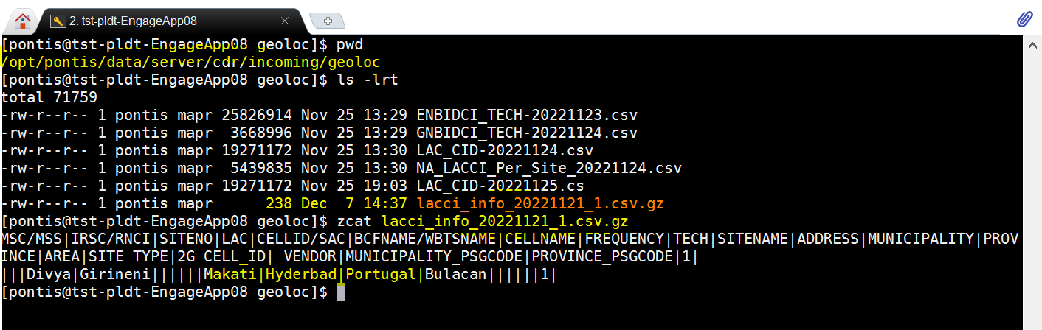

**Run the Geolocking CDR File Processor**



**Check in HBASE if table created**

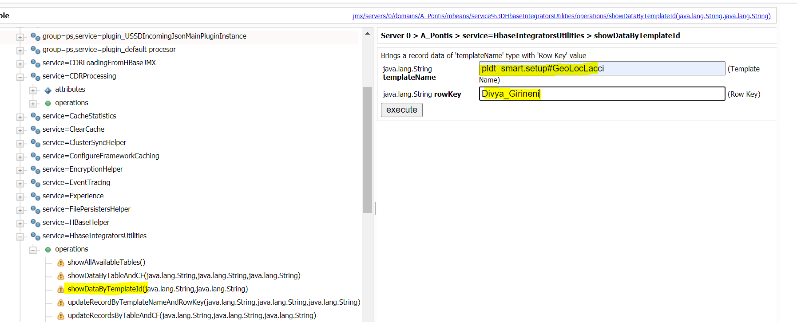

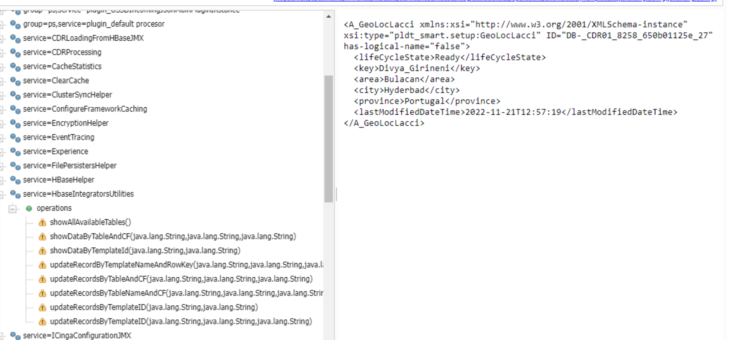

**Subscriber will be forwarded for "GEO_Loc" Experience**





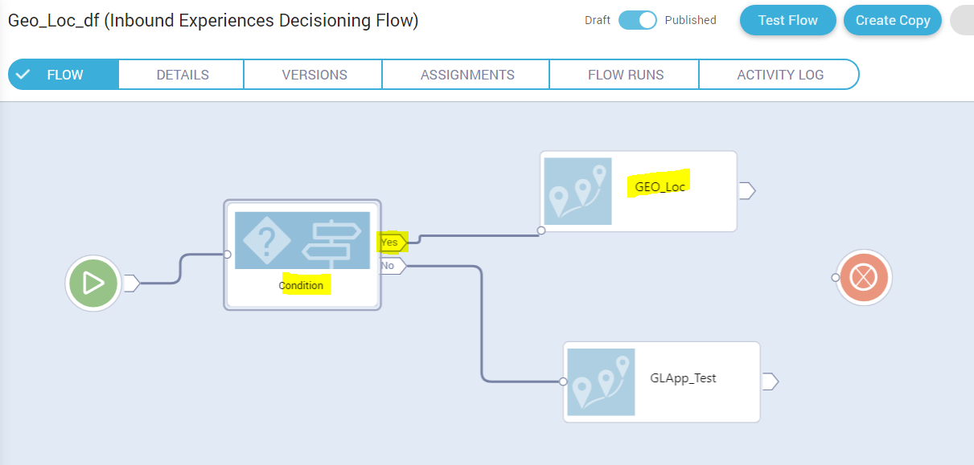

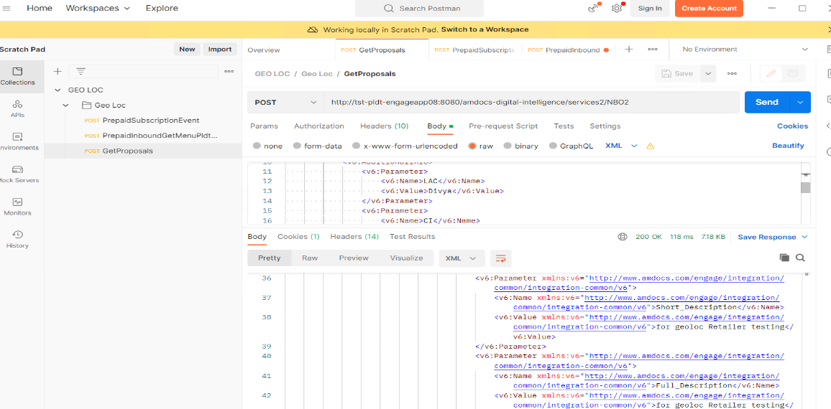

**Trigger Start Experience Event**

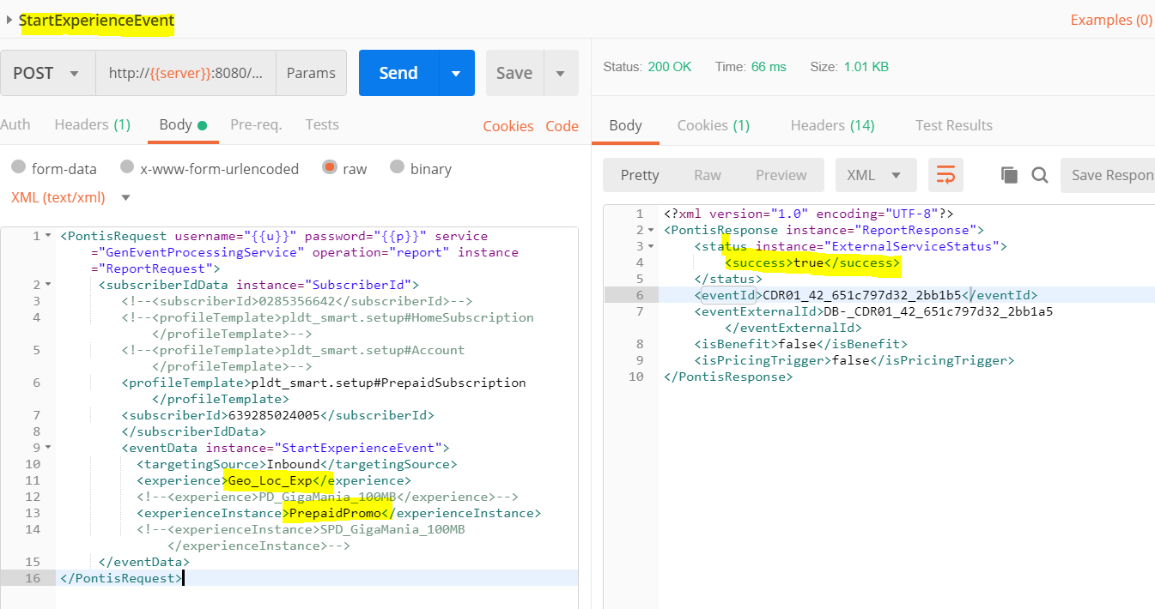

**Subscriber should receive Geo_Loc_Exp sms/benefit(if any)**

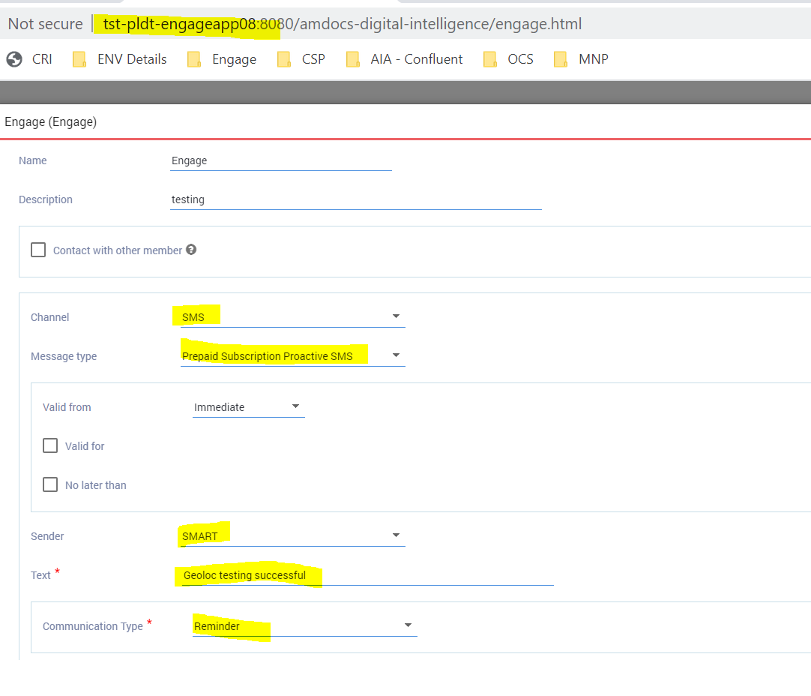

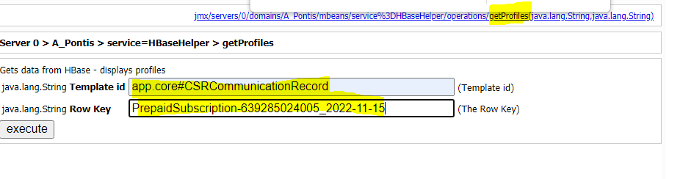

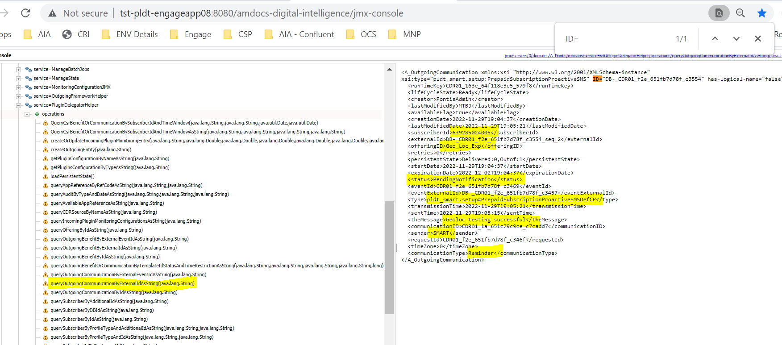

**File format is correct, but data is non-existent. Any random subscriber,hbase will be created, but when we push campaign, it will be filtered out only :**

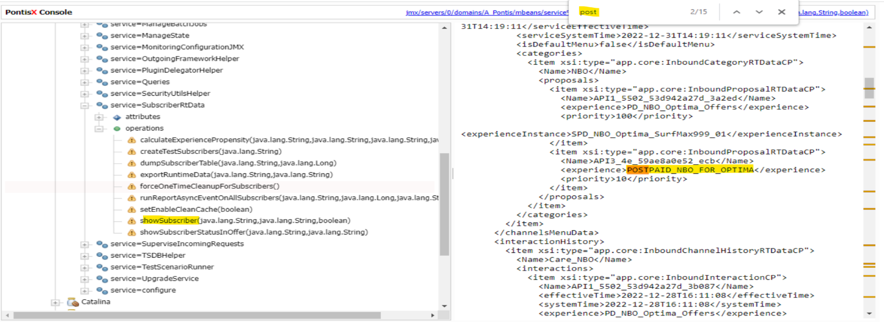

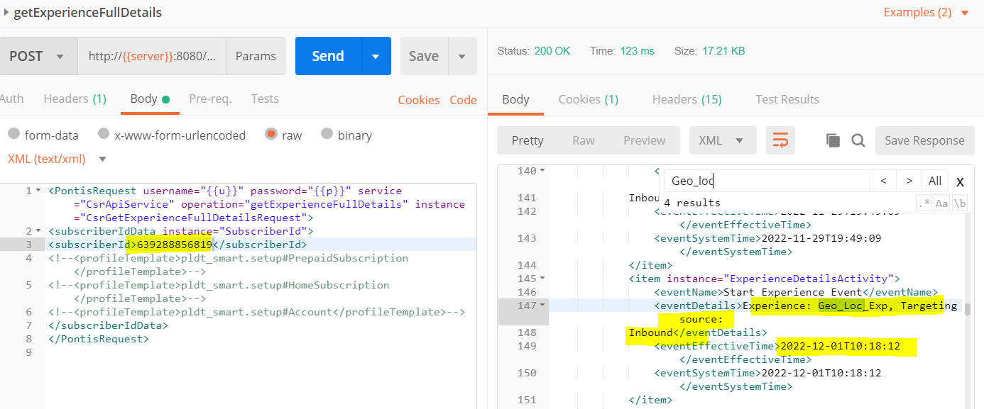

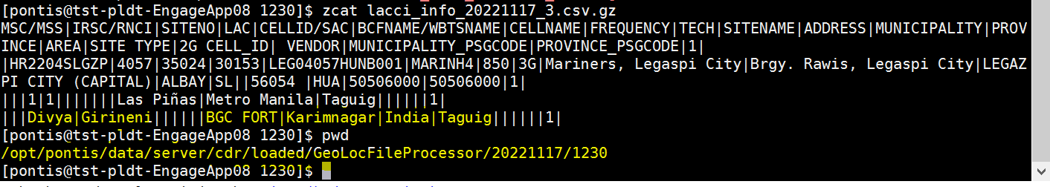

**HBASE Data Validation (SIT) :**

**Validate "key" parameter value LAC +"_" +CI from source**

**Validate "area" parameter from source**

**Validate "province" parameter from source**

**Validate "city" parameter having regular string from source**







**Validate "city" parameter having special string from source :**

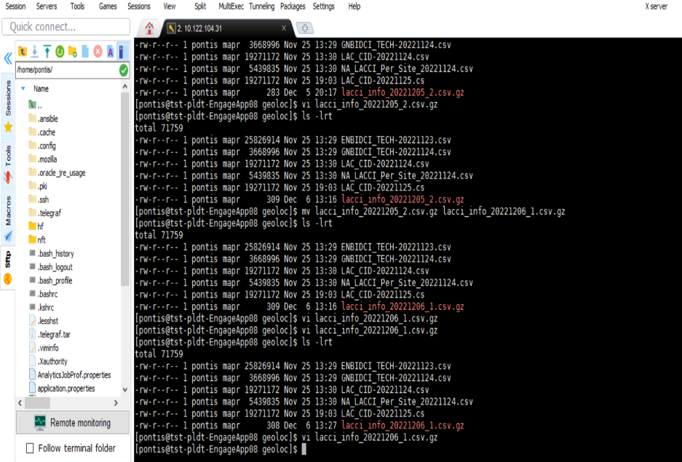

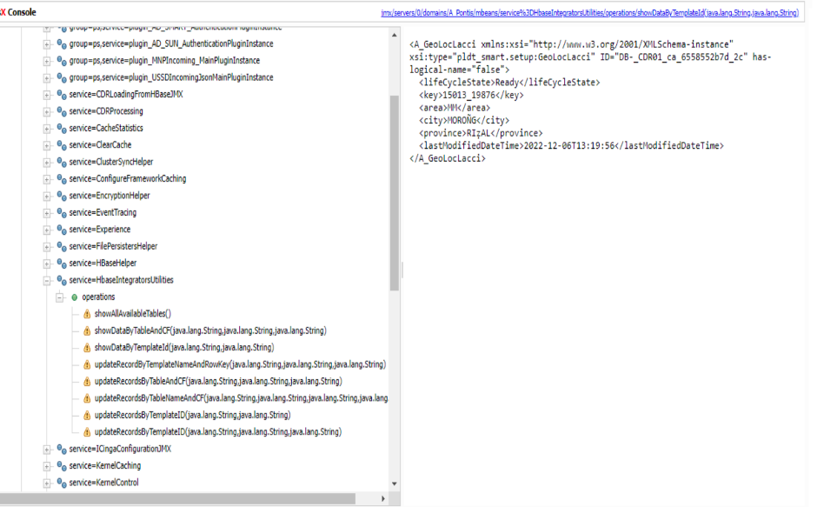

**Without LAC and CI value, current existing normal campaign should work without LAC and CI:**

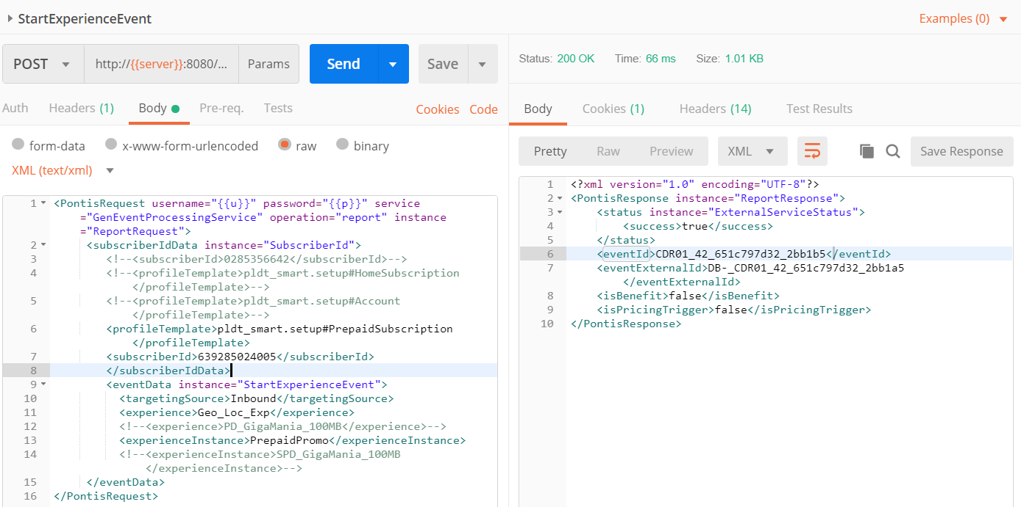

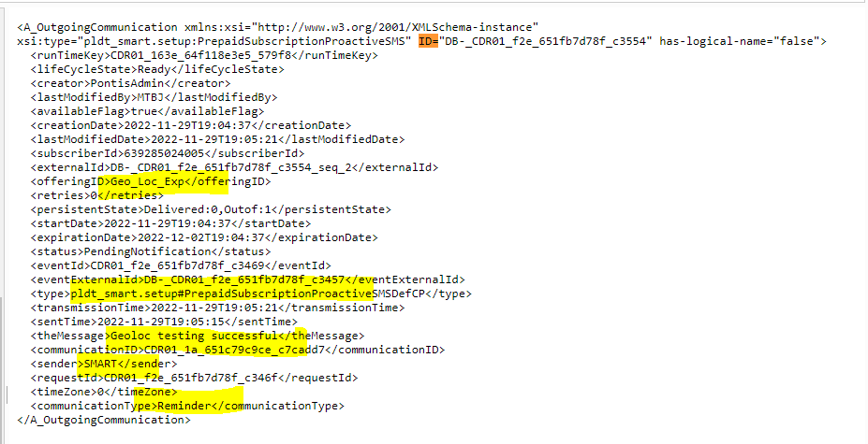

**Verify Input file from techdata (IAT) :**

**Input file should contain as per format and corresponding value mentioned from IDD and SRD. Check the Naspath is correct permissions for this new file and new file should be processed as expected:**

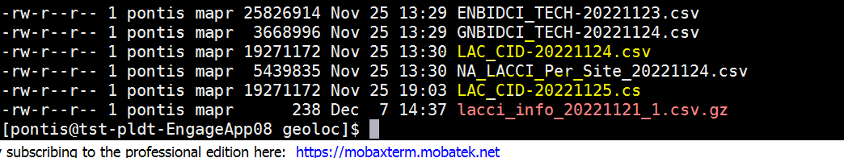

**validating if HBase table is already created :**

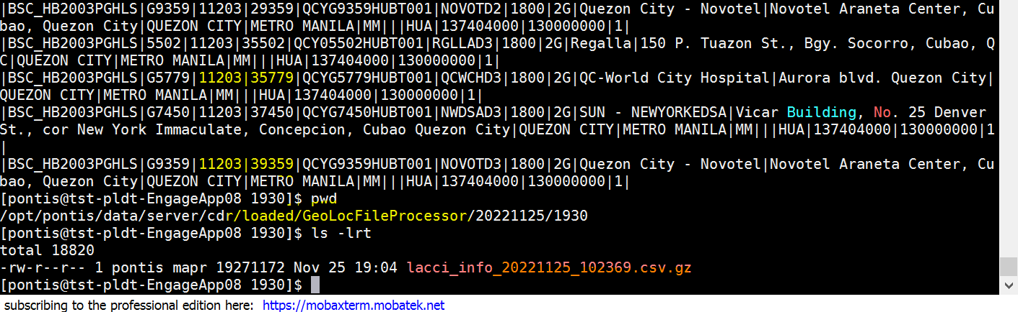

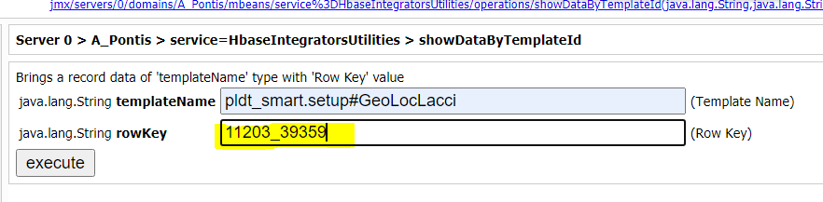

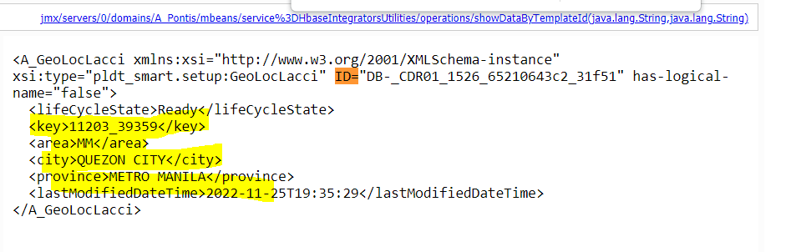

**CDR File Processor Validation (IAT) :**

**1.**

**Verify Hbase table"Geo_Loc_LACCI" is created, and data populated in Hbase table accordingly (4 attributes) with correct file_format:**



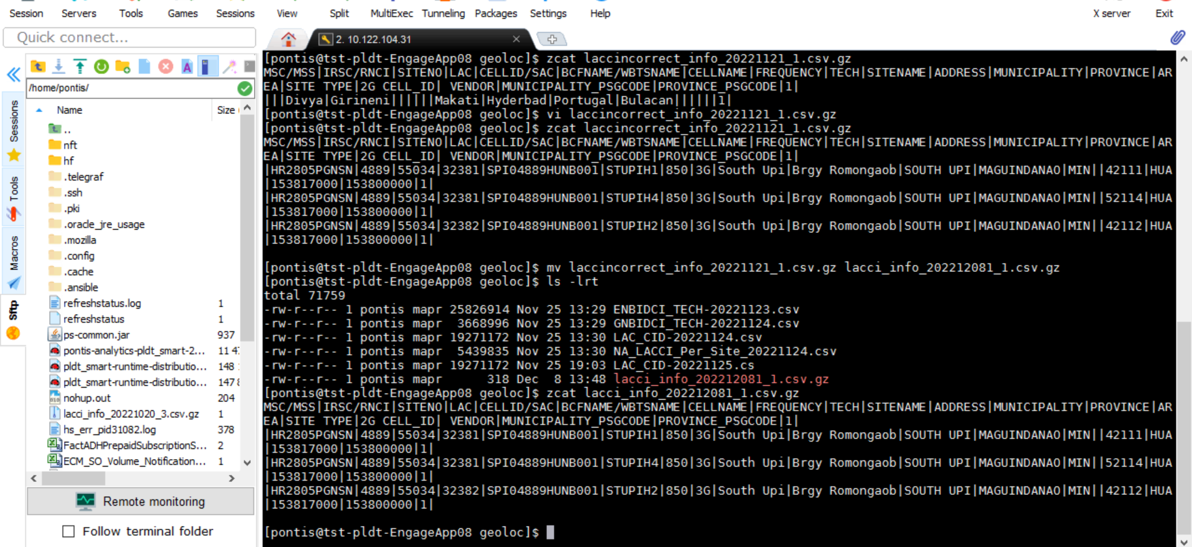





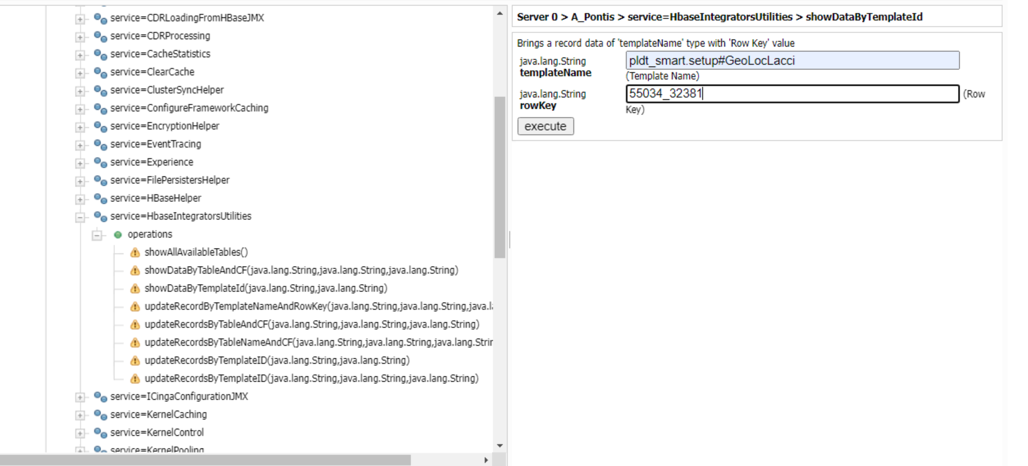

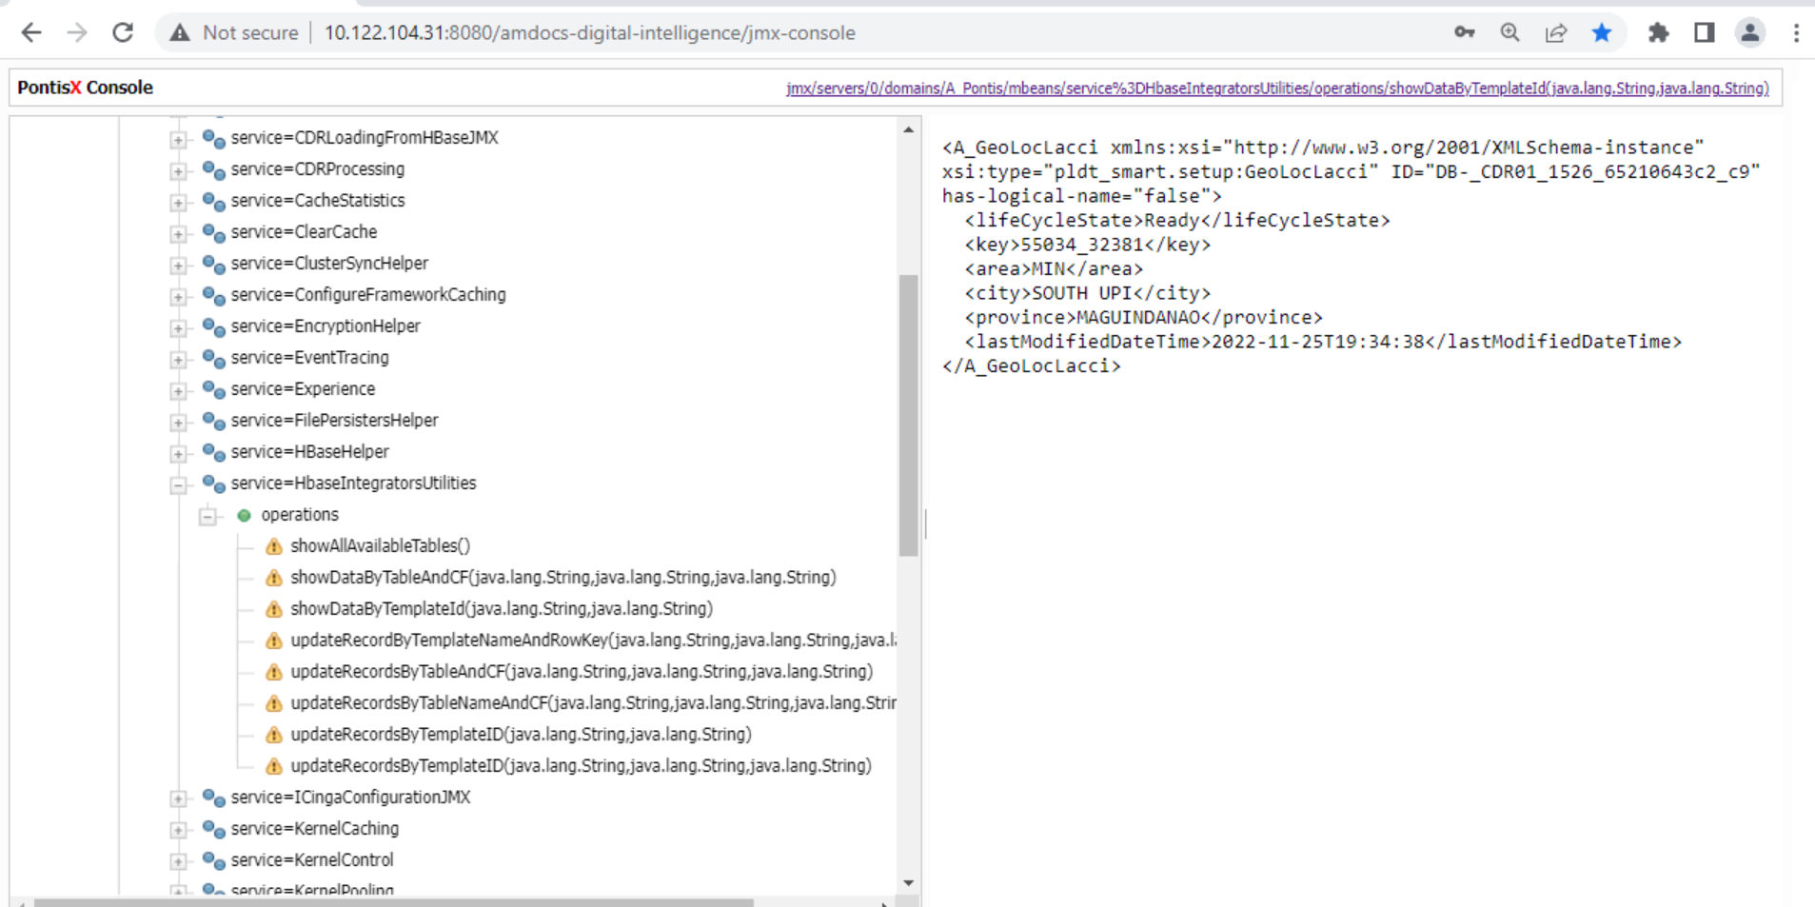

**2 .Verify existing attributes in Hbase (for same subscriber) are being updated as per configuration in the Input File from tech Data :**

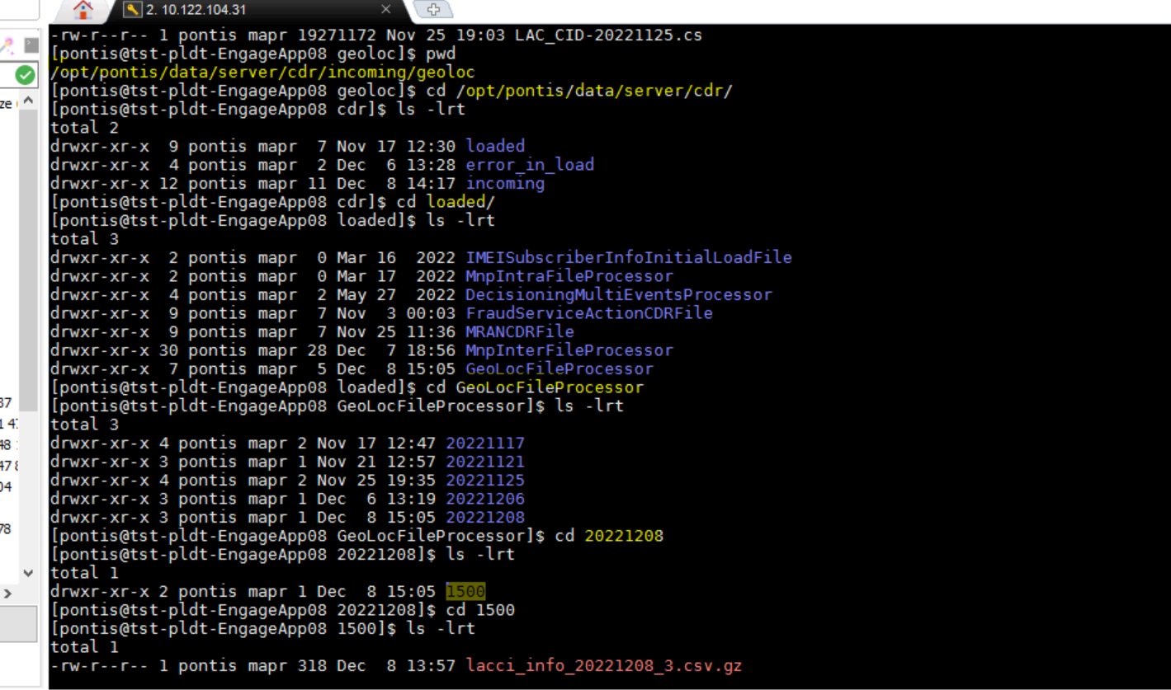

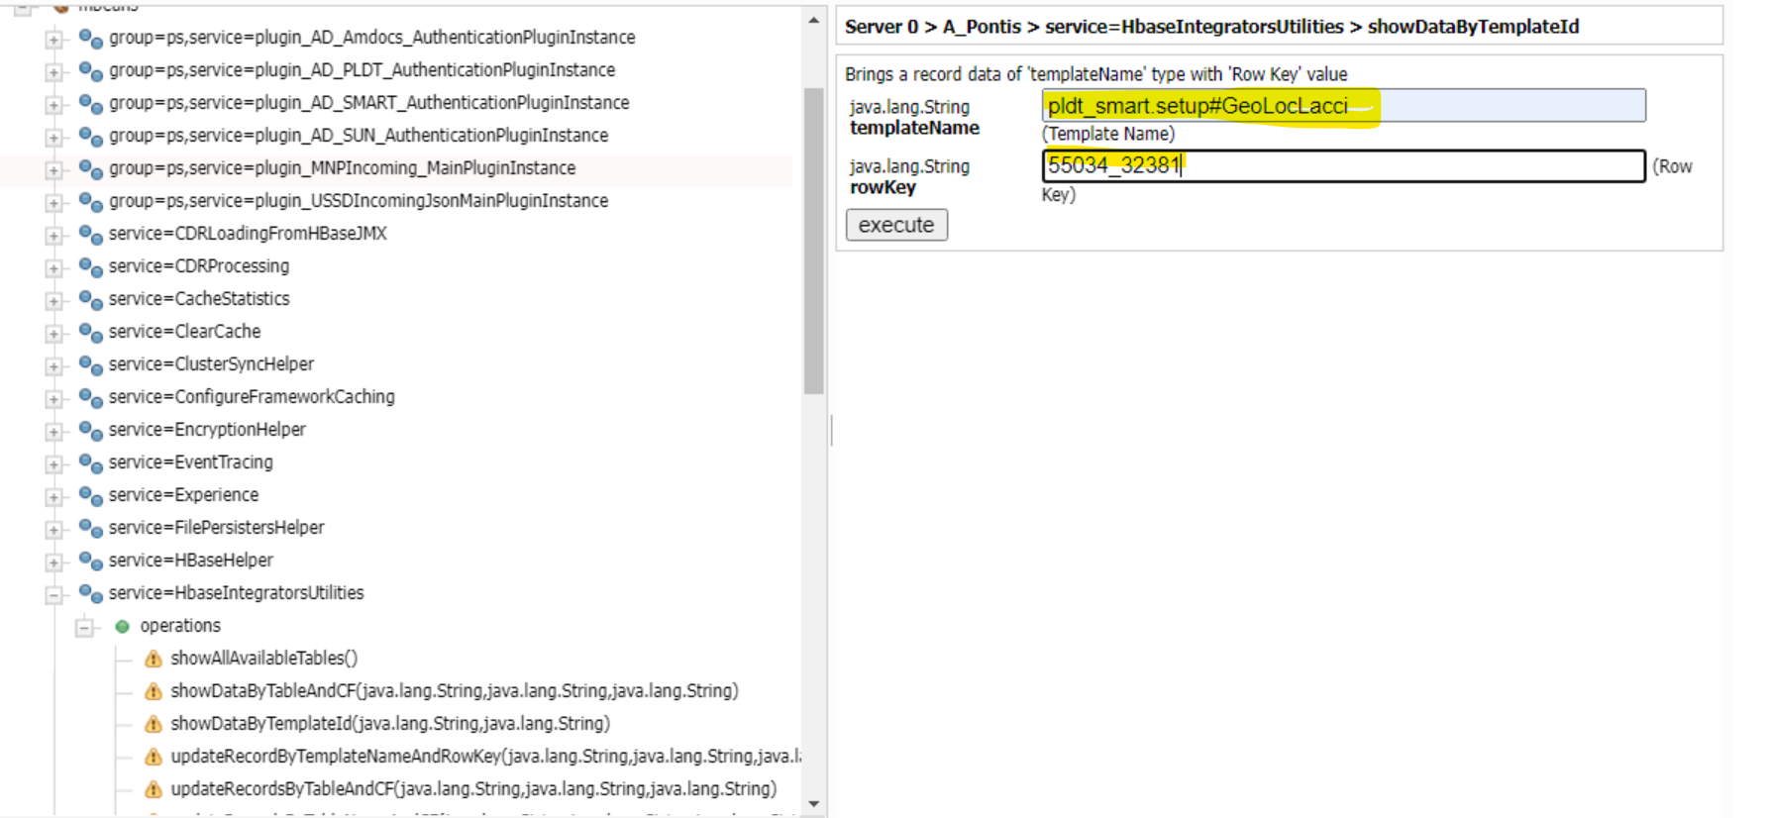

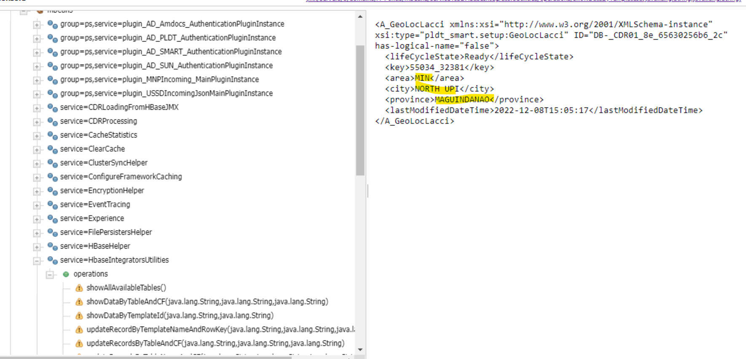

**3 .Verify Hbase table is not created for the subscriber with incorrect file_format :**

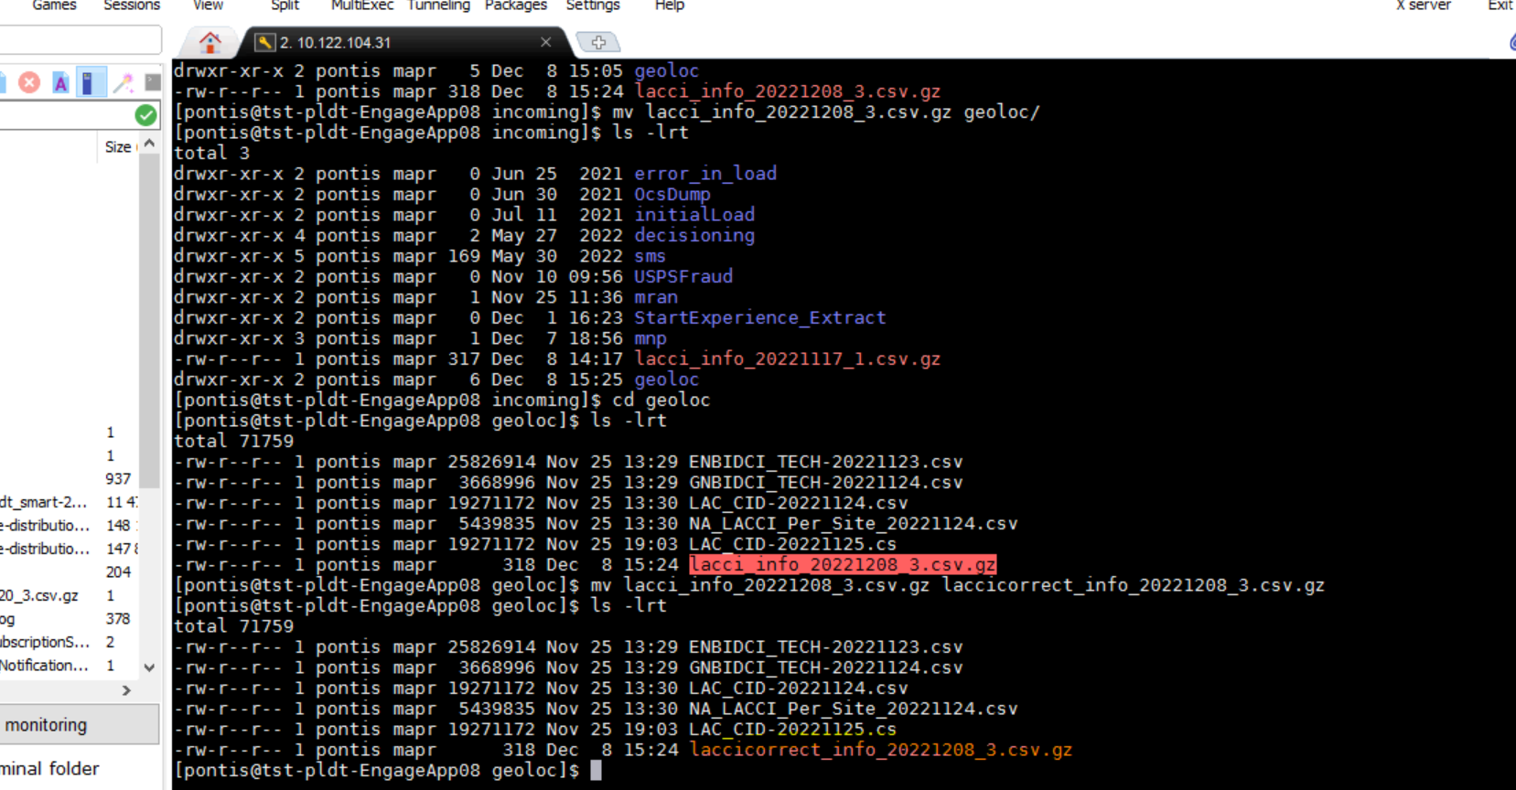

**4.For incorrect format file, it should be ignored**





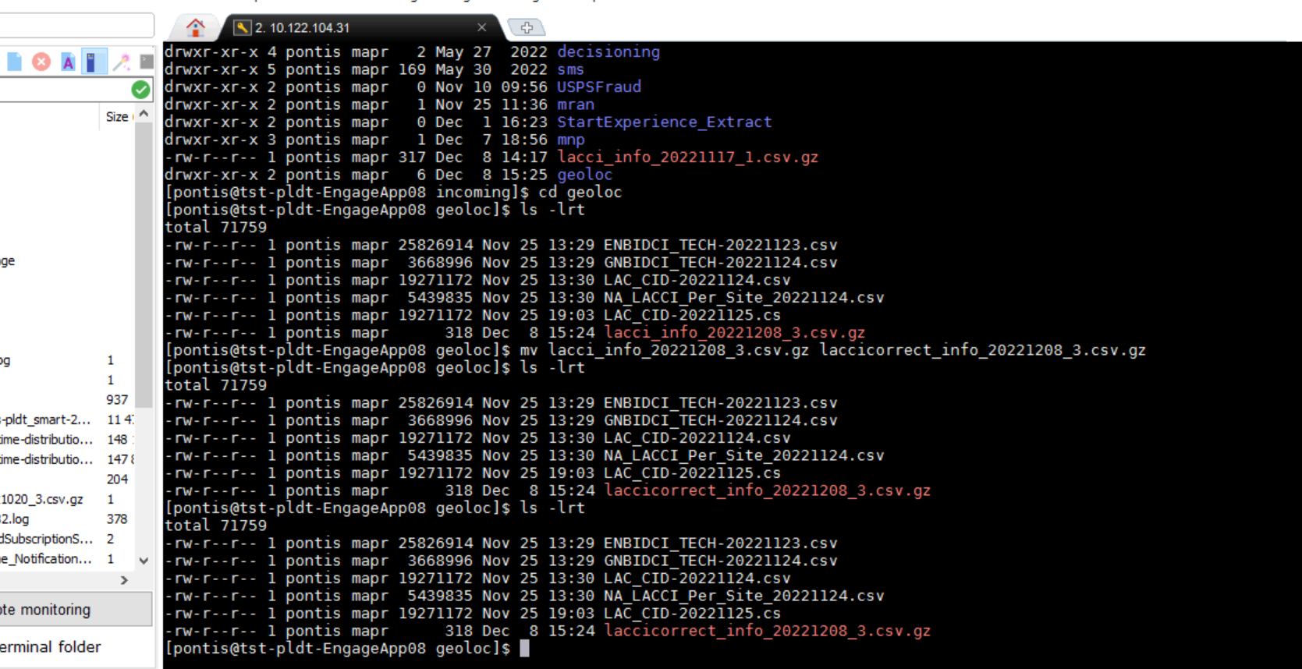

**The file is not consumed ignored because it is incorrect .**

**Decisioning Flow (IAT ):**

**1 .Validate "Geo_Loc_Exp" Experience (with false condition on city and province):**

**Prepare Input file to process with correct file name**



**Run the Geolocking CDR File Processor**



**Check in HBASE if table created**

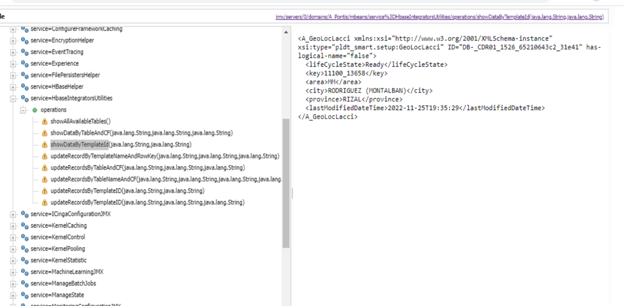

**Subscriber will be forwarded for "GLApp_Test" Experience :**







**Trigger Start Experience Event**



**Subscriber should receive GLApp_Test Benefit**

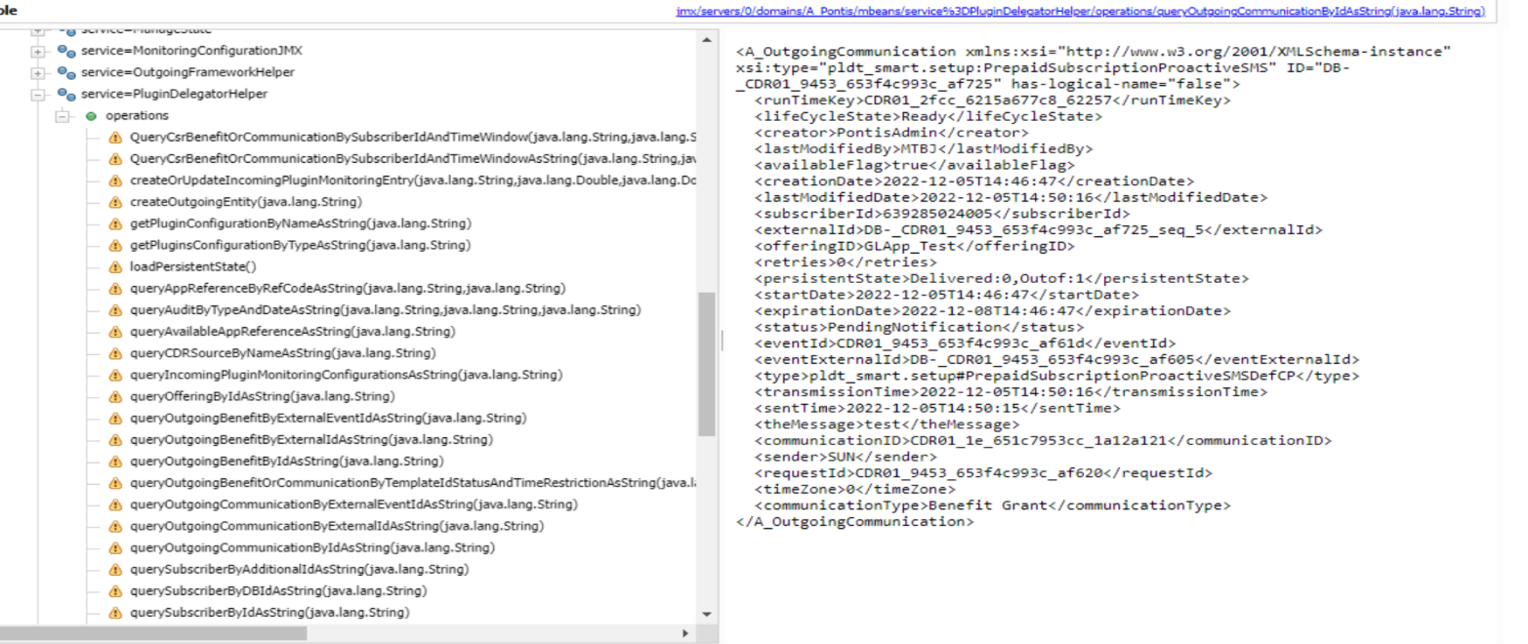

**2 .Validate "Geo_Loc_Exp" Experience (with Correct Condition on City and Province)**

**Prepare Input file to process with correct file name**

**Modify City and Province to"city:Hyderbad" and "province:Portugal"**



**Run the Geolocking CDR File Processor**



**Check in HBASE if table created**





**Subscriber will be forwardedfor "GEO_Loc" Experience**









**Trigger Start Experience Event**



**Subscriber should receive Geo_Loc_Exp sms/benefit(if any)**







**File format is correct, but data is non-existent. Any random subscriber,hbase will be created, but when we push campaign, it will be filtered out only :**

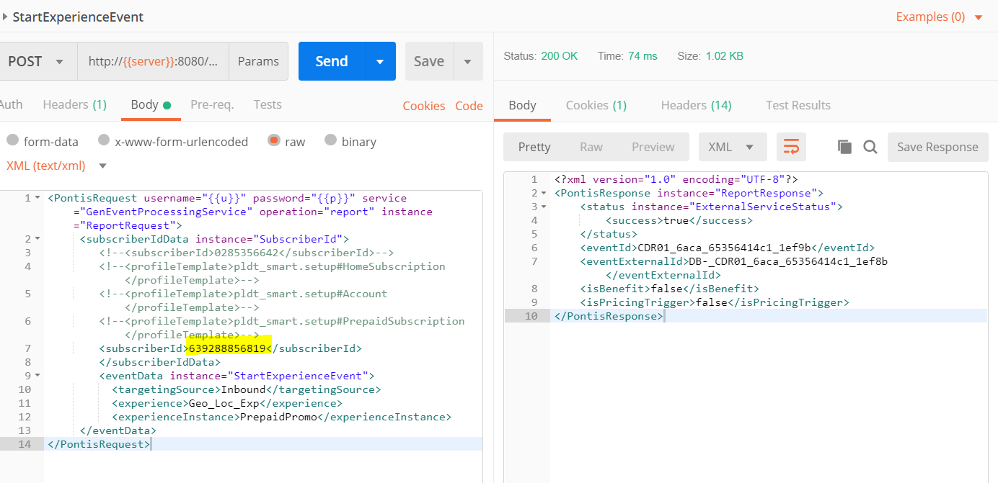



**HBASE Data Validation (SIT) :**

**Validate "key" parameter value LAC +"_" +CI from source**

**Validate "area" parameter from source**

**Validate "province" parameter from source**

**Validate "city" parameter having regular string from source**

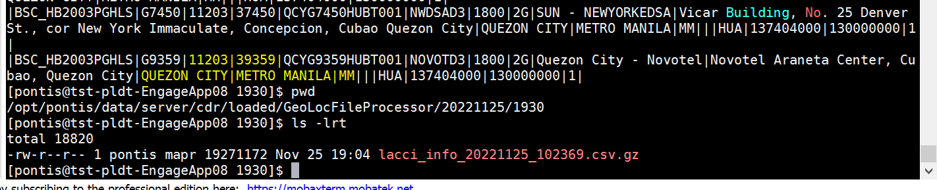



**Validate "city" parameter having special string from source :**





**Without LAC and CI value, current existing normal campaign should work without LAC and CI:**



